PHASE 2
Design Document

Rubiks Cube Timer
Picture

Developed by Nsovo Ngobeni

Signoffs
Phase | Teacher | Date | Signature
2) Design Document | Mrs Rajamany

1. Summary
Screen 1: Timer Screen
The first screen is the timer screen that will let users record and time all their solves and show a short summary of their currents statistics. The screen will contain the following UI elements:
- Navigation bar to other screens
- A digital timer
- Control buttons (Start, Stop, Restart, Penalty, and DNF)
- Summary of Statistics (Average of last 3, 5, and 7 recorded times)
Screen 2: Trainer Screen
The trainer screen will help users learn and perfect their skills. It will display common solutions / algorithms to the scramble that the users will be able to practice. They will be able to track their progress in solving these common scrambles. The screen will have:
- Navigation to other screens
- A list of all the algorithms (common solutions) and their related statistics: average time, best time, and worst time
- Controls to practice an algorithm
Screen 3: Stats Screen
The stats screen will show all the players relevant statistics that have been derived from their times entered. All stats will be contains within small labeled containers. Statistics to be shown:
- Average times (avg of last 5, 7, 10 recorded times, avg of all times)
- Total time spent practicing
- Average change in time: Compares newly recorded times to previous times to try find a trend towards shorter or longer times
- Number of solves/records
- Solves completed
- Solves uncompleted
- Number of penalties applied
Screen 4: Help Screen
The help screen will display guides explaining the use and function of the app to the users. It will contain text alongside pictorial representations.

2. Interface Design ➔ GUI screens
≪This section summarizes the layouts of all the various screen layouts for the entire program. This section should describe ALL interfaces linking the program to the outside environment including the user and should detail all the screens needed to deliver all the functional requirements. Include screen descriptions, screen shots, data sources and data descriptions. The client should understand that the final product may not be exactly as listed here but the functionality will stay the same. During coding, we may merge or separate screens to achieve a nicer user interface and to promote reusability of components. ≫

These separate interface elements / environments are described in detail below:

≪Do the following for each screen: Draw a screen design AND fill in a description table. Screen captures from a design tool (including IDE), sketches and mock-ups are acceptable. N.B. No code is needed for this section.≫

Timer Screen:
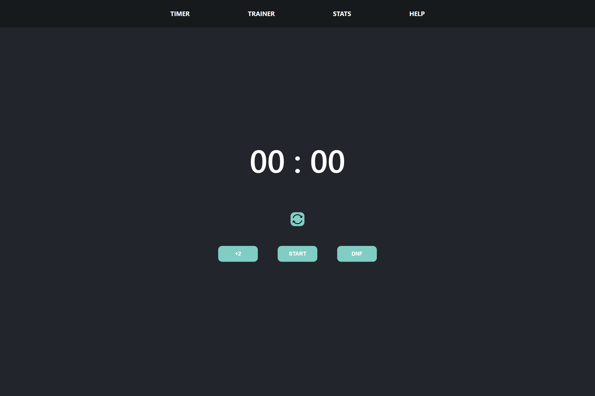

Description | The screen will let users record and save their times. Times recorded will be stored in an external database of solves
Security Group | Logged in users can access all their own data
Data | Time:  Data Type: Number  Storage: Stored in solves database
Actions | Restart Button:  Resets the time to 00:00  +2 Button:  Adds a 2 second penalty to the users final time  Start Button / Stop Button:  Starts the timer.  When started the start button will turn into a stop button  DNF Button:  Stops timer and records the time as null

Records Screen:
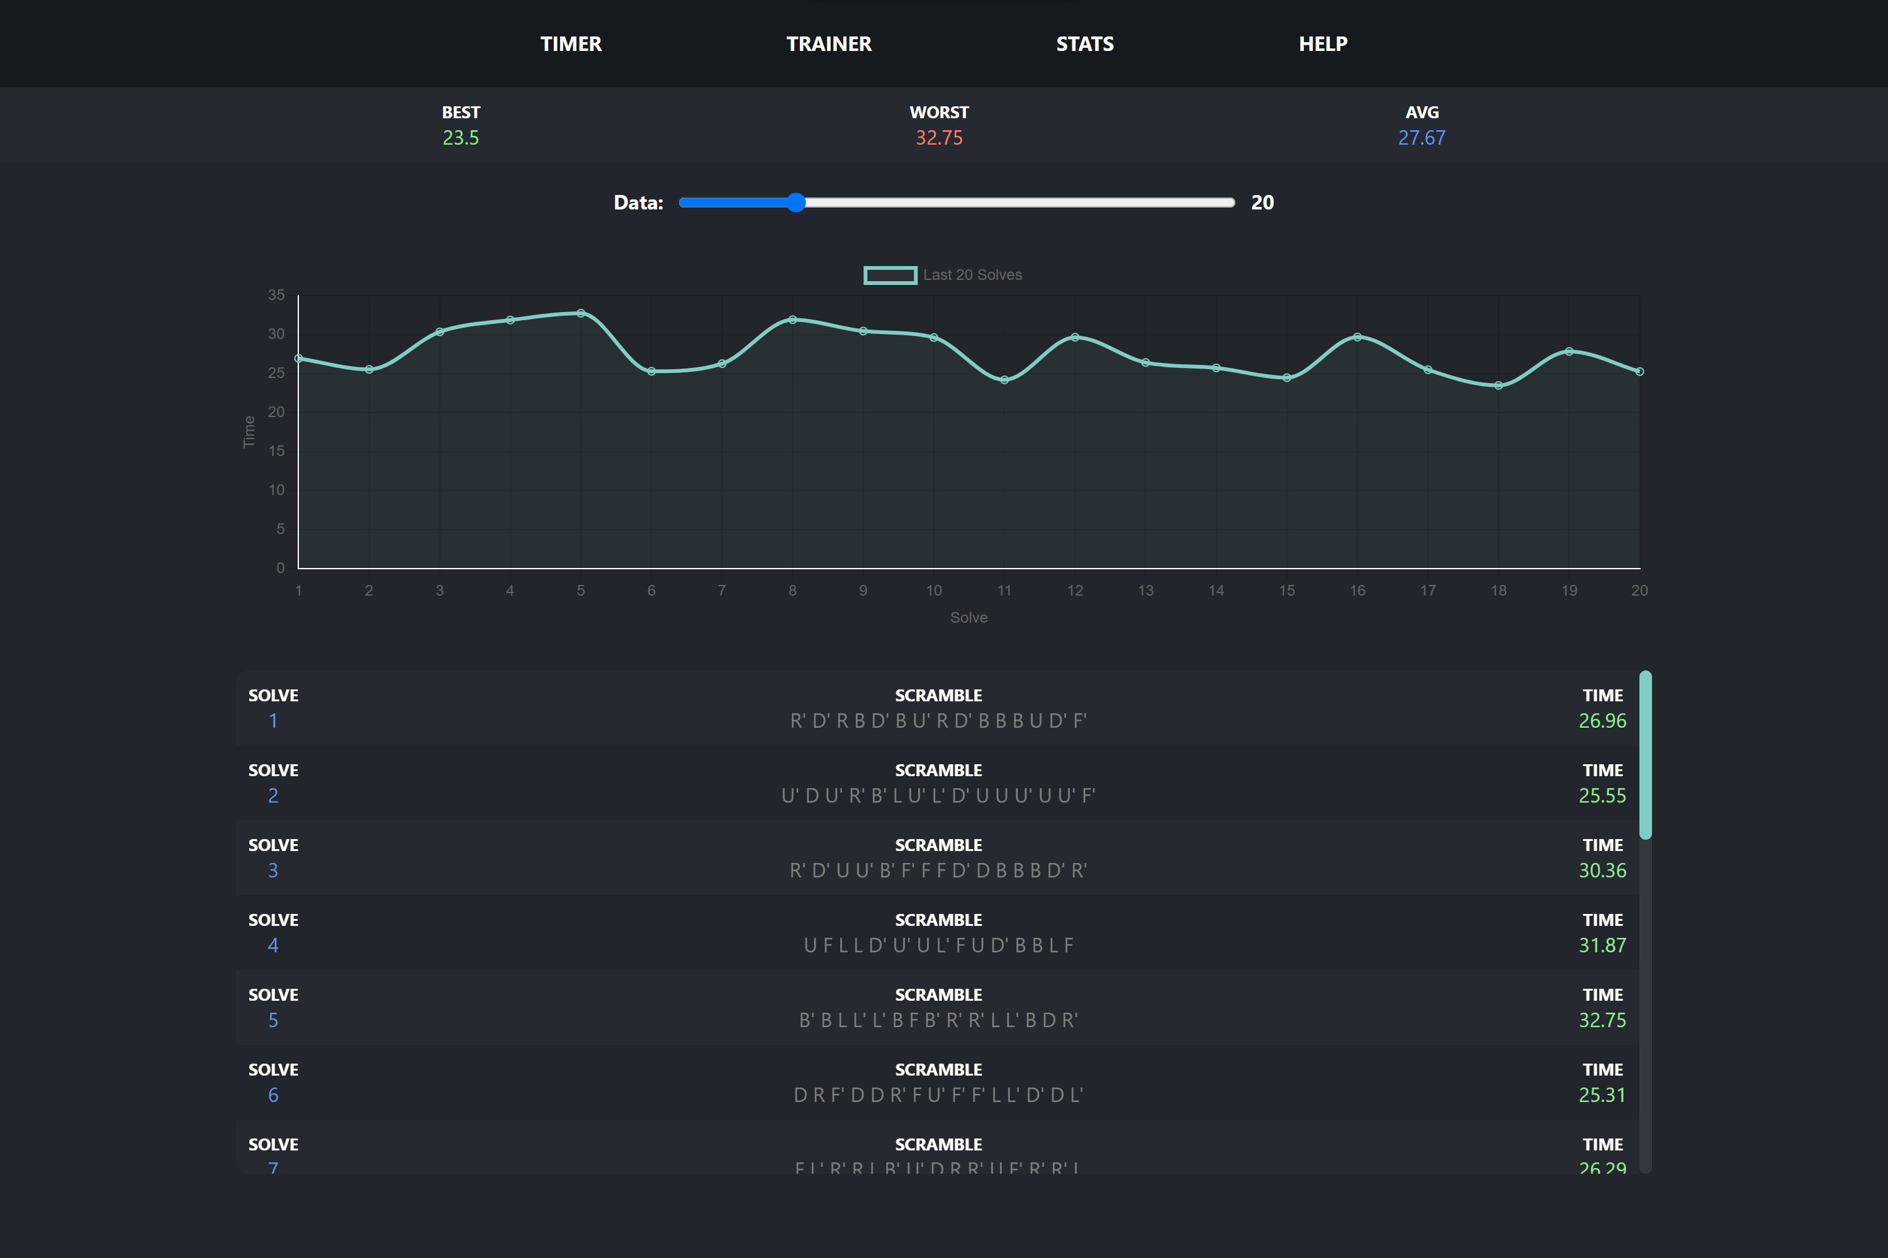

Description | The screen displays the users solve times through a dynamically rendered graph and list that update as the users results change and are added/removed
Security Group | Logged in users can access all their own data
Data | ID:  A unique ID used to identify each solve (optimizes app rendering)  Data Type: Calculated (Scramble + Time)  Scramble:  The scramble the user will solve  Data Type: Text Field  Time:  The time taken by the user to solve the scramble  Data Type: Number  Stored in solves database
Actions | Slider:  Changes the number of data entries loaded (last x sloves)

Trainer Screen:
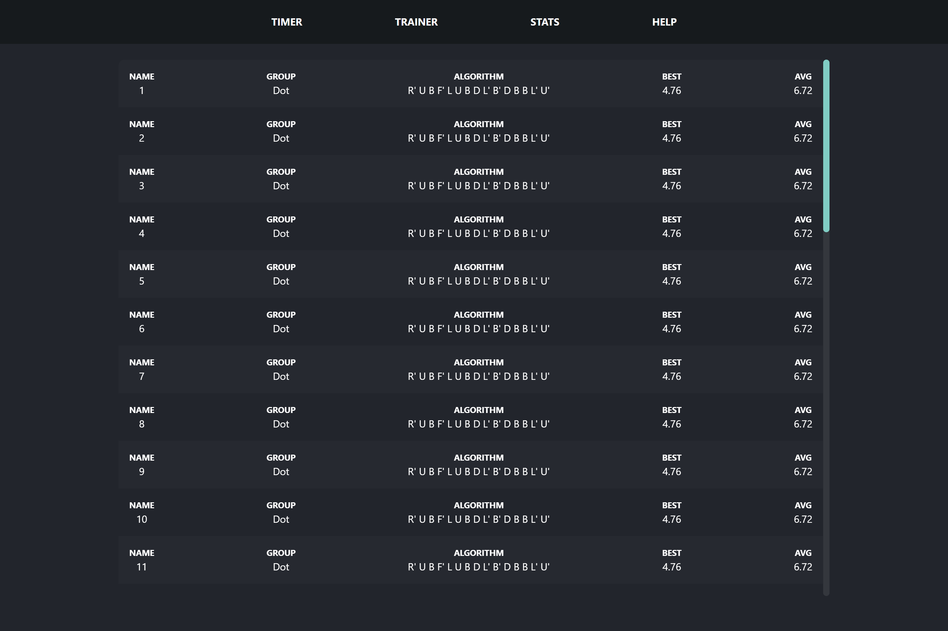

Description | The screen displays algorithms used to solve the cube and allows users to practice these algorithms and improve their times
Security Group | Logged in users can access all their own data
Data | Name:  The name of the algorithm  Data Type: Text field  Group:  Algorithms are grouped based on their type and solution  Data Type: Text field  Algorithm:  The algorithm practiced by the user  Data Type: Text field  Best Time:  The fastest time recorded by the user  Data Type: Number  Average Time:  The average of the last 20 times recorder by user  Data Type: Number  Algorithms stored in algorithms data base  Times stored in a related in times data base
Actions | Clicking an algorithm cell trigger a popup that will let users record their time

Popup Screen:
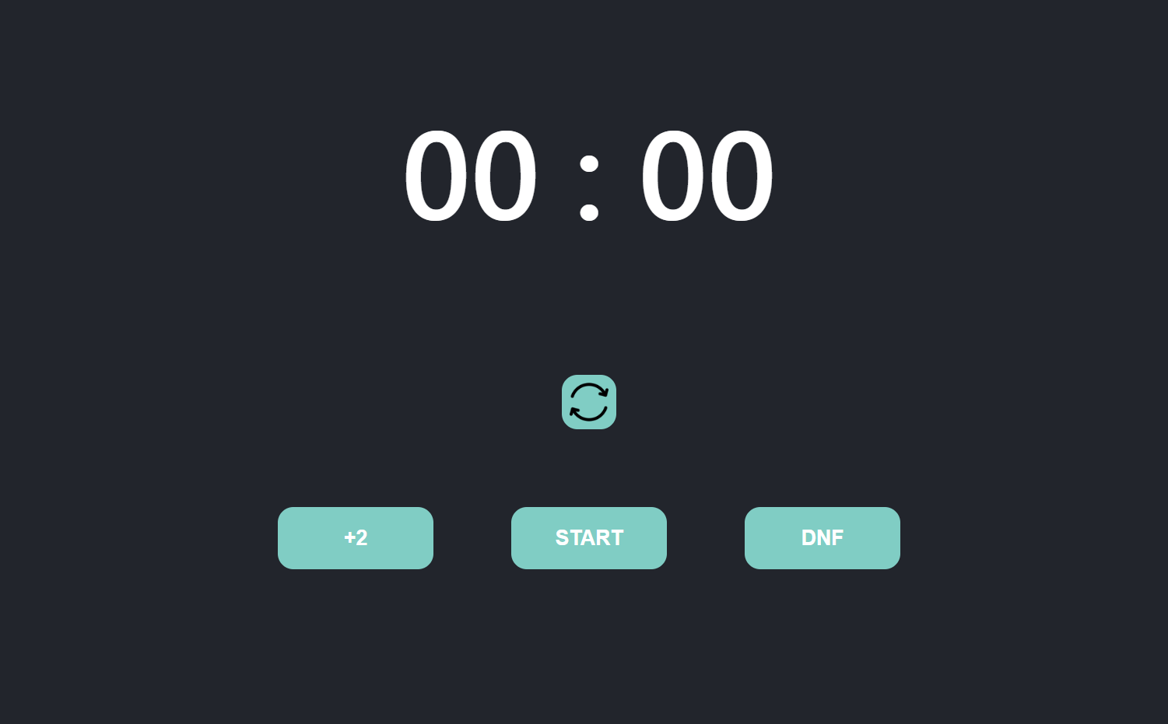

Description | The screen lets users record times for specific algorithms. It a reused version of the timer
Security Group | Logged in users can access all their own data. Data can also be recorded
Data | Time:  Data Type: Number  Storage: Stored in solves database
Actions | Reset Button:  Resets the time to 00:00  +2 Button:  Adds a 2 second penalty to the users final time  Start Button:  Starts the timer  (Start & Stop button interchange based on the timer running)  Stop Button:  Stops the timer and records the time  (Start & Stop button interchange based on the timer running)  DNF Button:  Time gets recorded as null

TODO:
- Stats Screen
- Help Screen

3. Program Flow ➔ Sequencing
≪Here you write down the sequence/flow of events that would happen in your program. Write it as a bulleted list. Must break sequencing into sections to cover all aspects of the functions and features of the specification document. Flow must be clear, well represented and easy to understand. NO LOGIC GAPS! The essential part(s) of the program must be planned using either Flow Diagram(s) or Algorithm(s). HINT: Copy in your features from your specification document as framework, and then fill in the sequencing, that way you will fulfill the specifications. Add in algorithm / SQL statements to explain more complex points. DO NOT do algorithms for basic programming techniques that were covered in class, e.g. sorting.≫

- Timer Screen is displayed
  - User presses start button (or space-bar) to start the timer
  - User can then press stop button (or space-bar) to stop the timer
  - If an infringement was made during the solve, a penalty can be added by clicking the +2 button
  - If the cube was not solved, the DNF button can be clicked to disqualify the solve
  - The reset button can then be clicked to save the time to the database and reset the timer to 00:00 for the next solve
  - Users can navigate throughout the app using the navigation bar
- Record Screen is displayed
  - User can change the number of records displayed using the slider
  - User can scroll through the records
  - Users can navigate throughout the app using the navigation bar
- Trainer Screen is displayed
  - User can scroll through all algorithms used to solve the cube
  - Each algorithms displays the average time and best time the user finishes it.
  - Clicking on algorithm will open up a pop up timer screen that allows users to record new timers for the algorithm
- Stats Screen is displayed
  - User can see all relevant stat data
    - Average, Best, and Worst of Last 5, 7, 12 and 20
    - Scrambles Started / Scrambles Finished
    - Total Time

4. Class design ➔ Objects / Classes to be developed
≪You must design every class AND explain your choice of classes, fields and methods. Methods and fields must clearly relate back to the specifications document!≫

≪Fill in the following for each class ≫
Class Name:
Purpose of class:
Fields
Field Name | Data type | Description
Methods
Method name | Data type (if typed) / void | Description

5. Secondary Storage Design ➔ Database Layer
Table name: | Solves
Links / Relationships:
Fields: | Field name | Data type | Description
Fields: | ID | Calculated | A unique ID comprised of the Scramble and the Time taken to solve it
Fields: | Scramble | Short Text | A unique scramble generated randomly
Fields: | Time | Number | The time (in milliseconds) taken to solve the scramble

Explanation of secondary data storage
≪You must explain your choice of data storage and fields and data types. Describe which data is stored how and why you chose to store it this way. The explanation must demonstrate a justification of the secondary storage design and an understanding of the implications of the chosen design≫

Explanation of Primary Data Structure related to Secondary Storage
<< Provide a description of how the primary data structure described in the class diagrams will represent the secondary storage design. There should be a description for each backend class listed in the class diagrams above that will translate the data to and from secondary storage >>

Table name: | Algorithms
Links / Relationships: | Times
Fields: | Field name | Data type | Description
Fields: | ID | Auto Number | A unique ID assigned
Fields: | Algorithm | Short Text | A unique scramble generated randomly

≪For any text file used, explain the layout, e.g. name, surname and password≫

Explanation of secondary data storage
≪You must explain your choice of data storage and fields and data types. Describe which data is stored how and why you chose to store it this way. The explanation must demonstrate a justification of the secondary storage design and an understanding of the implications of the chosen design≫

Explanation of Primary Data Structure related to Secondary Storage
<< Provide a description of how the primary data structure described in the class diagrams will represent the secondary storage design. There should be a description for each backend class listed in the class diagrams above that will translate the data to and from secondary storage >>

Table name: | Times
Links / Relationships: | Algorithms
Fields: | Field name | Data type | Description
Fields: | Algorithm ID | Foreign Key | The ID of the solve
Fields: | Time | Number | The time (in milliseconds) taken to complete the algorithm

≪For any text file used, explain the layout, e.g. name, surname and password≫

Explanation of secondary data storage
≪You must explain your choice of data storage and fields and data types. Describe which data is stored how and why you chose to store it this way. The explanation must demonstrate a justification of the secondary storage design and an understanding of the implications of the chosen design≫

Explanation of Primary Data Structure related to Secondary Storage
<< Provide a description of how the primary data structure described in the class diagrams will represent the secondary storage design. There should be a description for each backend class listed in the class diagrams above that will translate the data to and from secondary storage >>

